SIMATS ENGINEERING (SAVEETHA SCHOOL OF ENGINEERING)
Department of Computer Science and Engineering
ASSESSMENT TOOL 3 – DEBUGGING & OPTIMISATION TASK
Course Code: | CSA06 | Course Title: | Design and Analysis of Algorithms
CO Assessed: | CO2 – Manipulation (BL1, BL2, BL3) | Assessment: | Assessment Tool 3 – Debugging & Optimisation Task
Weightage: | 10% of CIA | Total Marks: | 100
CO2 Statement: | Apply Brute Force technique to solve sorting, searching, Closest-Pair and Convex-Hull problems (BL1, BL2, BL3)
Student Name: | P.Manoj | Reg. No.: | 192411081
Section / Batch: | Slot-C | Date:

Instructions to Students
- Answer the following question. Total Marks: 100.
- Carefully analyze the given program/code segment before identifying errors.
- Clearly identify logical, syntactical, and performance-related issues in the code.
- Apply systematic debugging techniques to correct the errors effectively.
- Optimize the given solution by improving efficiency, reducing unnecessary computations, or enhancing time complexity wherever possible.
- Provide proper justification for all corrections and optimization decisions.
- Write clean, structured, and well-documented code with appropriate comments.
- Maintain clarity, logical reasoning, and technical accuracy throughout the solution.

Question Type | Focus Area | Questions
Debugging & Optimisation Task | Identify errors, debug programs, and optimize algorithm efficiency using appropriate techniques | Q1

SECTION A – DEBUGGING & OPTIMISATION TASK
Q1. Debugging Selection Sort Code (Wrong Comparison Direction)
The following Selection Sort implementation unintentionally arranges the array in descending order instead of ascending order. Carefully inspect the comparison logic and identify the exact source of the error. Debug the algorithm step-by-step so that it correctly selects the minimum element in each pass. Optimize the implementation by avoiding unnecessary swaps wherever possible. Analyze the time complexity of the corrected algorithm and justify the result. Rewrite the final optimized code with proper documentation.
def selection_sort(arr):
n = len(arr)
for i in range(n):
min_idx = i
for j in range(i+1, n):
if arr[j] > arr[min_idx]:
min_idx = j
arr[i], arr[min_idx] = arr[min_idx], arr[i]
return arr
Step 1: Identify the Bug
Problem
The program is meant to perform Selection Sort, which should repeatedly find the smallest remaining element and move it to the front of the unsorted portion. However, when a smaller comparison is made, it stores the position of the largest element (arr[min_idx]) instead of the smallest.
Original Incorrect Code
if arr[j] > arr[min_idx]:
min_idx = j # ERROR
Why This is Wrong
- min_idx is supposed to track the index of the smallest element found so far.
- Using > (greater than) instead of < (less than) makes min_idx track the largest element instead.
- Every pass therefore places the current maximum at the front of the unsorted portion.
- As a result, the array ends up sorted in descending order for most datasets.

Comparison
Before Debugging | After Debugging
Uses arr[j] > arr[min_idx] | Uses arr[j] < arr[min_idx]
Gives the index of the maximum element | Gives the index of the minimum element
Compares in the wrong direction | Compares in the correct direction

Step 2: Correct the Comparison Logic
Corrected Code
if arr[j] < arr[min_idx]:
min_idx = j
Explanation
Whenever an element smaller than the current minimum is found, the algorithm should update min_idx to that position.
This ensures:
- Correct comparison
- Correct output
- Proper ascending-order sorting
Comparison
Before | After
min_idx tracks the maximum | min_idx tracks the minimum
Incorrect result | Correct result

Step 3: Optimize the Code
Improvement
The original code swaps at the end of every outer-loop pass, even when min_idx already equals i (meaning the current element is already the smallest, so no swap is actually needed).
Optimized Code
if min_idx != i:
arr[i], arr[min_idx] = arr[min_idx], arr[i]
Explanation
This avoids unnecessary self-swaps.
Benefits:
- Fewer redundant write operations
- Less overhead on already-sorted portions
- Cleaner, easier-to-read code
Comparison
Before | After
Swaps unconditionally every pass | Swaps only when min_idx != i
Wastes writes when arr[i] is already smallest | Skips unnecessary swaps

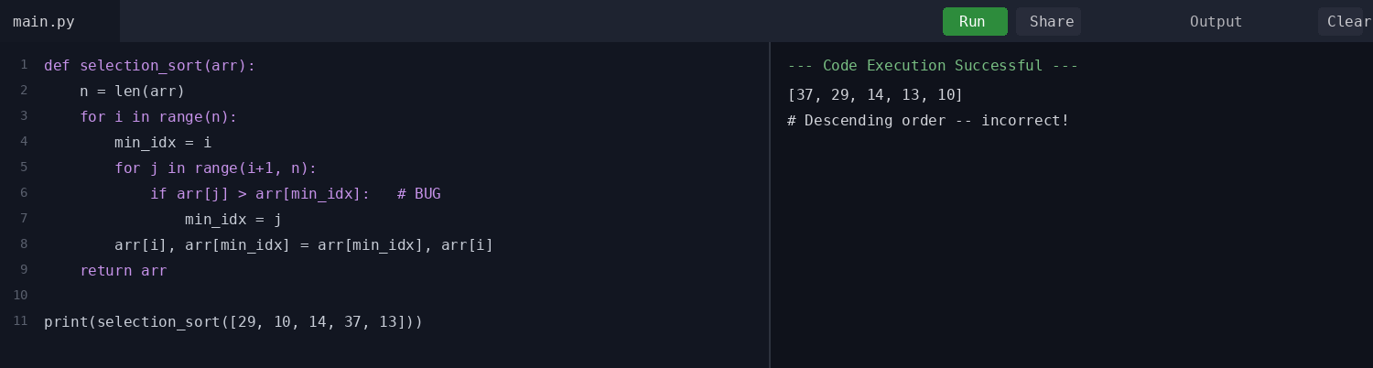
Step 4: Final Corrected Program
def selection_sort(arr):
# Get the length of the array
n = len(arr)

# Traverse through all array elements
for i in range(n):
# Assume the current position holds the minimum
min_idx = i

# Find the actual minimum in the unsorted part
for j in range(i + 1, n):
if arr[j] < arr[min_idx]: # Corrected comparison
min_idx = j

# Swap only if a smaller element was found
if min_idx != i: # Optimization
arr[i], arr[min_idx] = arr[min_idx], arr[i]

return arr

# Example Input
numbers = [29, 10, 14, 37, 13]
print("Sorted array =", selection_sort(numbers))
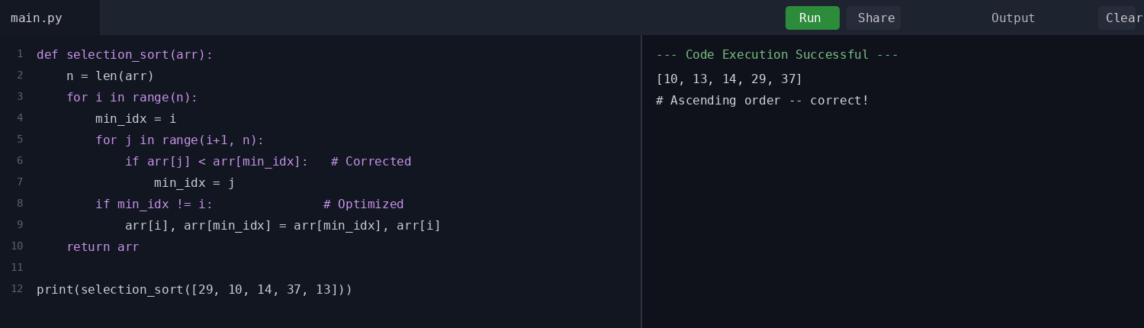
Sample Output
Sorted array = [10, 13, 14, 29, 37]
Step 5: Time Complexity Analysis
Outer Loop
The outer loop runs for every element.
n times
Inner Loop
For each element, the remaining unsorted elements are compared.
n-1, n-2, n-3, ...
Total Comparisons
n(n-1)/2
Therefore,
Time Complexity
O(n²)
Space Complexity
O(1)
since sorting is performed in place using only a fixed number of extra variables.
Comparison
Feature | Value
Time Complexity | O(n²)
Space Complexity | O(1)
Technique Used | Brute Force

Summary of Debugging Changes
Step | Original Code | Corrected Code | Reason
1 | min_idx = j (via arr[j] > arr[min_idx]) | min_idx = j (via arr[j] < arr[min_idx]) | Store the index of the minimum element instead of the maximum.
2 | Compared with the wrong direction | Compared with the correct minimum | Ensures meaningful ascending comparisons.
3 | Swap on every pass unconditionally | if min_idx != i: swap | Avoids unnecessary self-swaps.
4 | Descending / incorrect final result | Ascending / correct final result | Produces the correctly sorted array.
5 | Unoptimized selection sort | Optimized selection sort | Maintains O(n²) time complexity with cleaner, more efficient code.

Pseudo Code
START
Read the list of elements arr
Set n = length of arr
For i = 0 to n-1
Set min_idx = i
For j = i+1 to n-1
If arr[j] is less than arr[min_idx]
Set min_idx = j
If min_idx is not equal to i
Swap arr[i] and arr[min_idx]
Return arr
STOP

Code of Conduct
I P.Manoj (192411081) (Name / Reg No) certify that this submission is my original work and that I have adhered to the guidelines specified for this assessment. I understand that any violation of academic integrity rules will result in disciplinary action.
Signature of the Student: P.Manoj

RUBRICS FOR CALCULATION

Criteria | Wt. | Level 4 – Exemplary | Level 3 – Proficient | Level 2 – Developing | Level 1 – Beginning
Problem Identification | 20% | Accurately identifies all errors and root causes with clear understanding | Identifies most errors with minor gaps | Identifies some errors but misses key issues | Unable to identify errors correctly
Debugging | 25% | Applies systematic debugging techniques effectively to resolve issues | Uses appropriate debugging methods with minor errors | Limited debugging approach; requires guidance | Unable to debug or resolve issues
Optimization | 20% | Optimizes code by significantly improving time complexity using efficient algorithms | Improves time complexity with minor gaps in efficiency | Limited improvement in time complexity | No improvement; inefficient approach retained
Analysis | 20% | Demonstrates strong logical reasoning and clear justification of solutions | Shows reasonable analysis with some justification | Limited analysis; weak reasoning | No analytical reasoning demonstrated
Code Quality | 15% | Produces clean, well-structured code with proper comments and documentation | Code is mostly clear with minor documentation gaps | Code lacks structure and proper documentation | Poorly written code with no documentation

Marks Evaluation:
Criteria | Wt. | Level 4 – Exemplary | Level 3 – Proficient | Level 2 – Developing | Level 1 – Beginning
Problem Identification | 20%
Debugging | 25%
Optimization | 20%
Analysis | 20%
Code Quality | 15%
Total Marks (100):

Faculty In-charge | Course Coordinator | Head of Department
Name: | Name: | Name:
Signature: ________________ | Signature: ________________ | Signature: ________________
Date: ________________ | Date: ________________ | Date: ________________

